SFC Placement System User Manual
Table of Contents
Introduction 2
System Architecture 2
Installation 3
Prerequisites 3
Setup Steps 3
Configuration 3
Configuration Files 3
System Configuration 4
Basic Usage 5
Part 1: VNF Placement 5
Example output: 6
Part 2: VNF Placement with Redundancy 6
Example output: 7
Algorithms 7
VNF Placement Algorithms (Part 1) 7
Backup VNF Placement Algorithms (Part 2) 8
Input/Output Files 8
Input Files 8
Output Files 8
System Components 9
Core Classes 9
Setup Components 10
Troubleshooting 10
Common Issues 10
Advanced Usage 10
Custom Topology Generation 10
Custom SFC Creation 11
Performance Tuning 11

Introduction
The SFC Placement System is a tool for optimizing the placement of Virtual Network Functions (VNFs) in network infrastructures. It addresses key challenges in modern networks by considering multiple optimization criteria:
- Availability: Ensures high service reliability
- Carbon Footprint: Minimizes environmental impact
- Latency: Optimizes performance
- Trade-offs: Balances competing objectives
The system supports two main operations:
- Primary VNF placement (Part 1)
- VNF placement with redundancy optimization (Part 2)

System Architecture
The SFC Placement System follows a layered architecture:
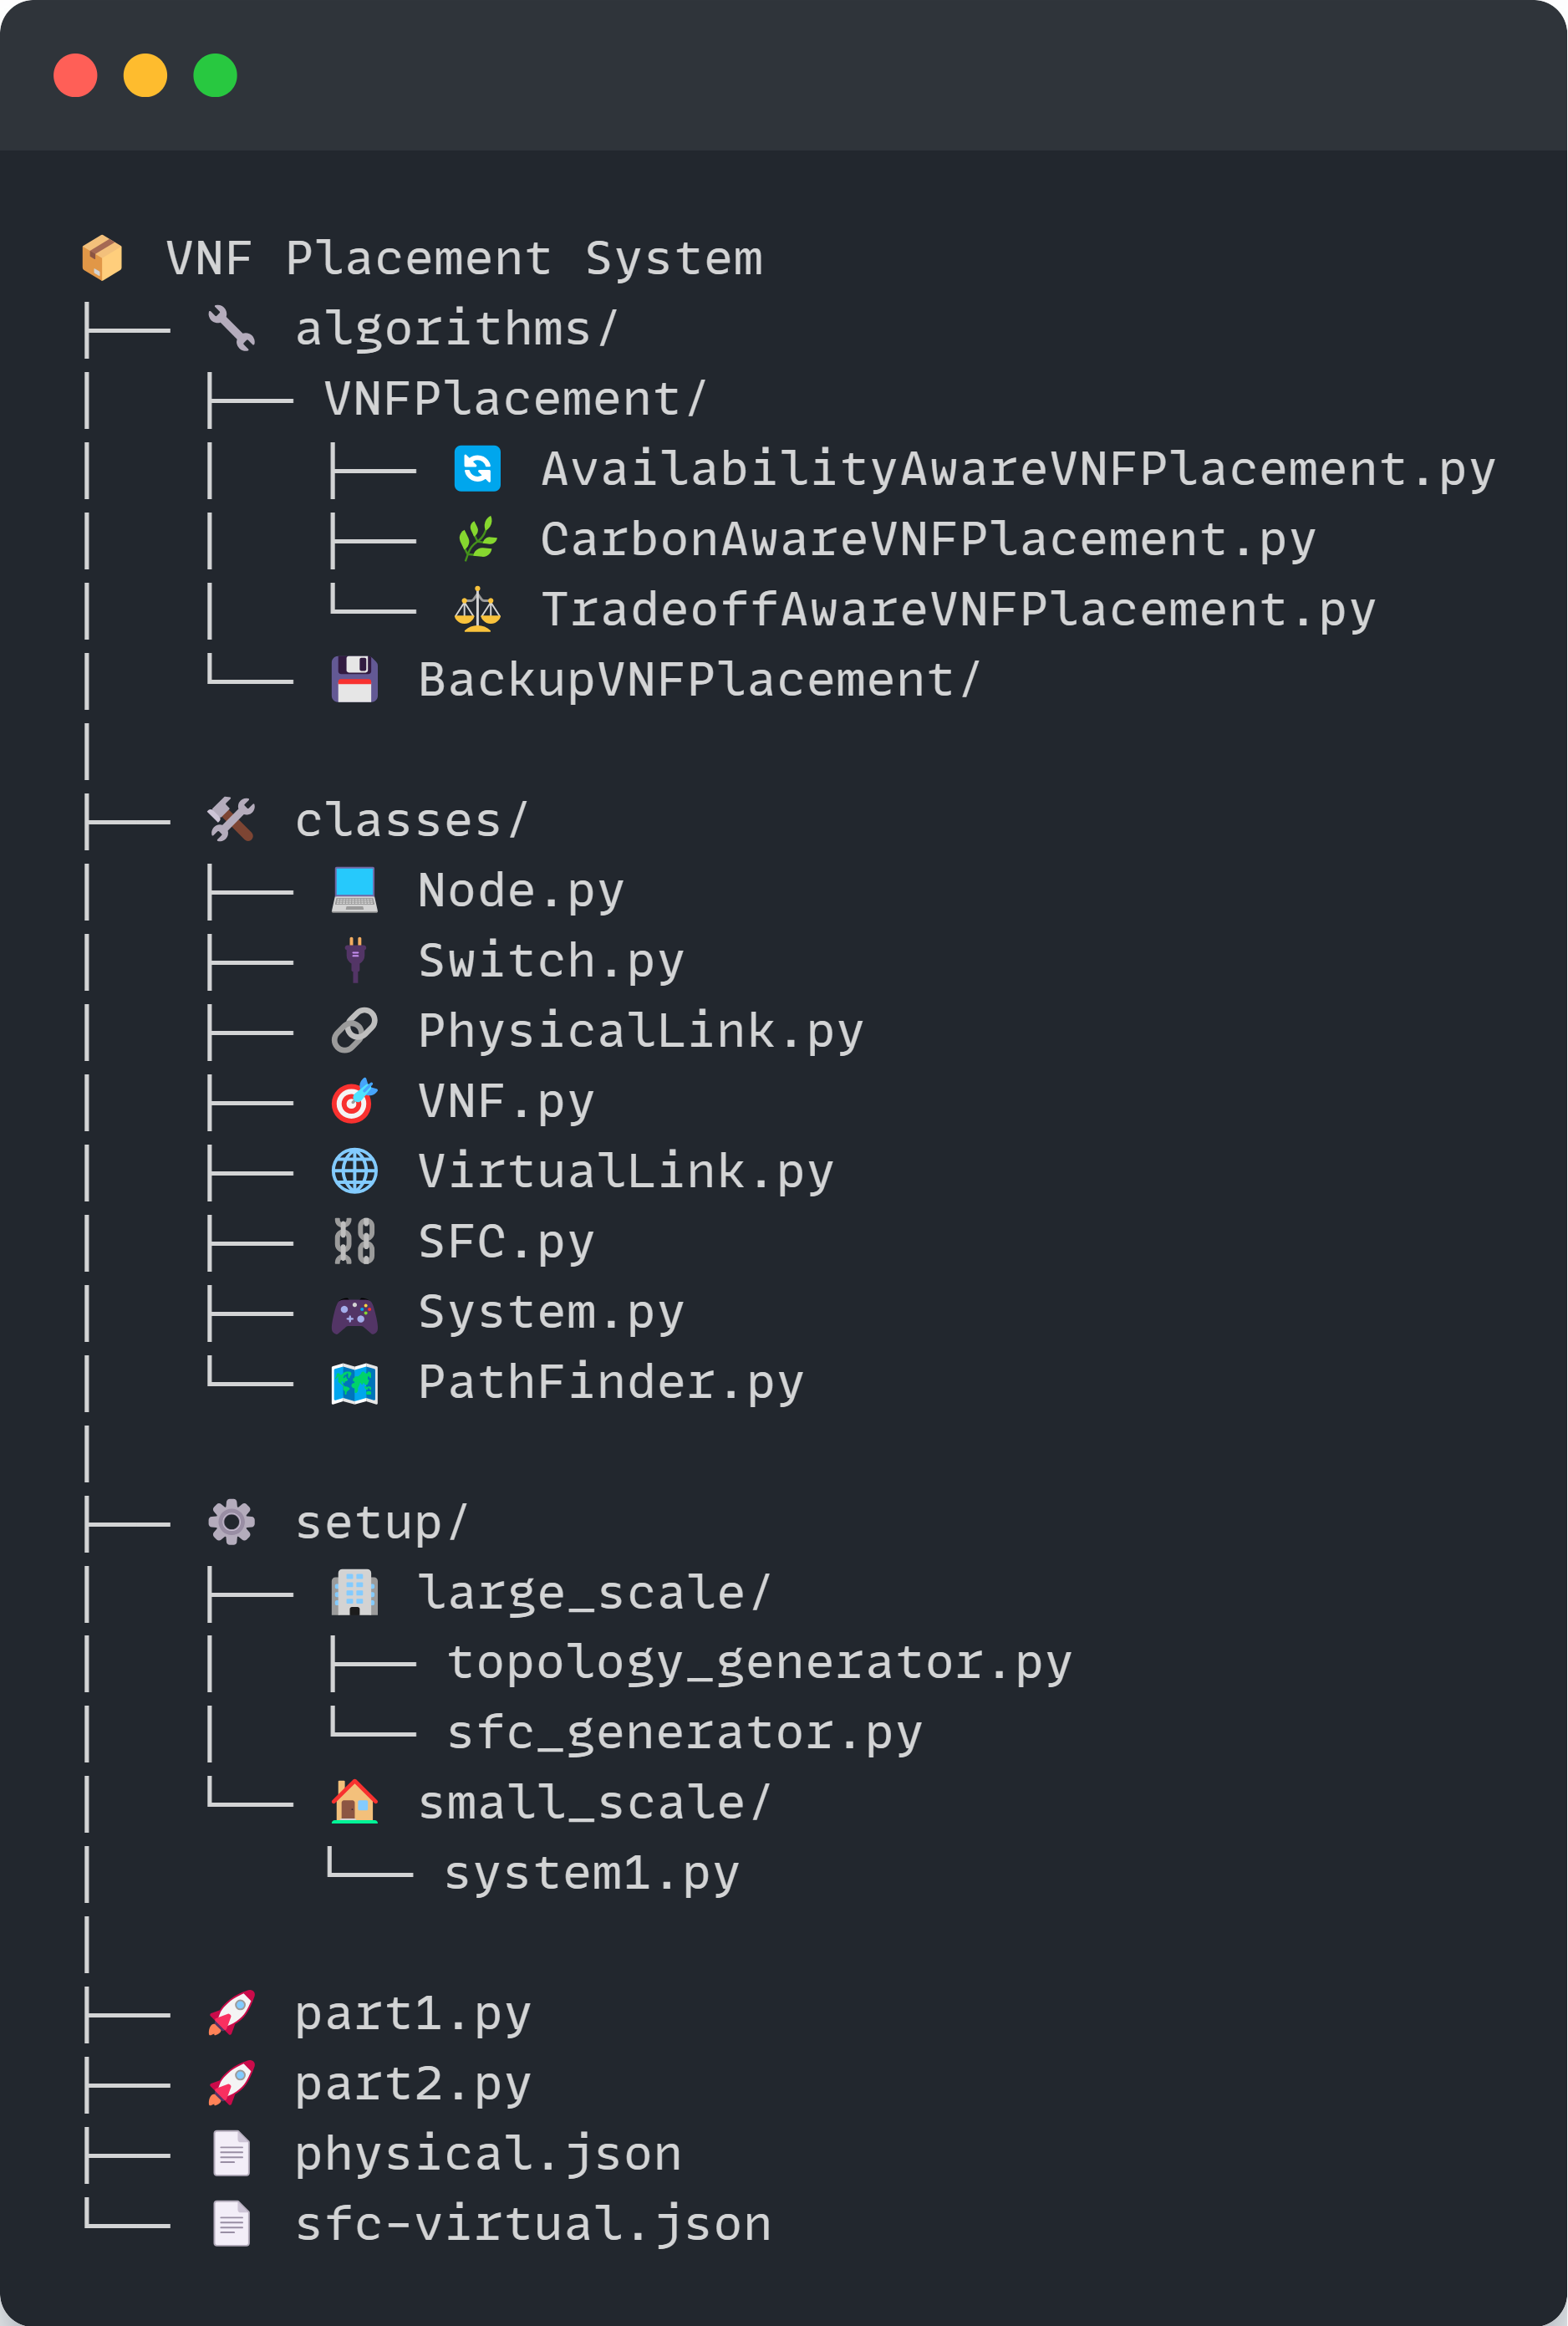
The architecture consists of:
- Physical Infrastructure Layer: Nodes, switches, and physical links
- Virtual Service Layer: VNFs, virtual links, and service function chains (SFCs)
- Optimization Layer: Placement algorithms and backup strategies
- Configuration Layer: System settings and topology definitions

Installation

Prerequisites
- Python 3.7 or higher
- Required Python packages
- Git (for repository cloning)
- 4GB RAM minimum (8GB recommended for large topologies)

Setup Steps
- Clone the repository:
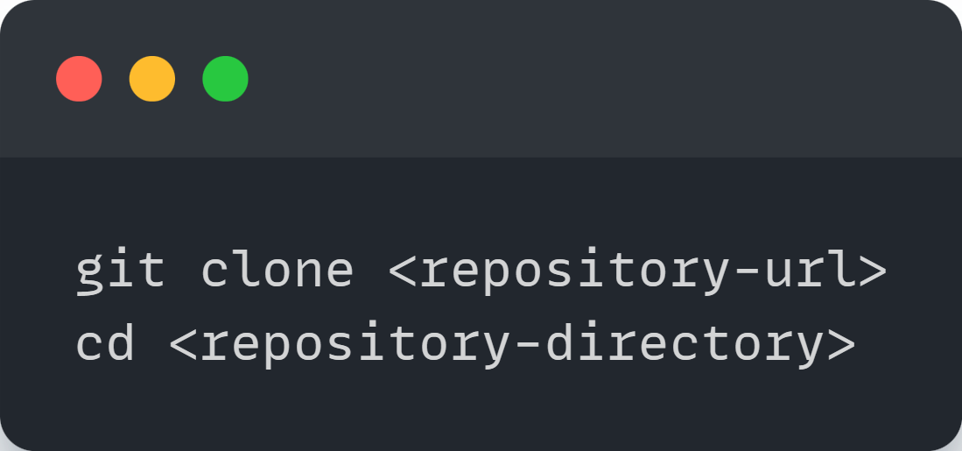
- Install required dependencies:
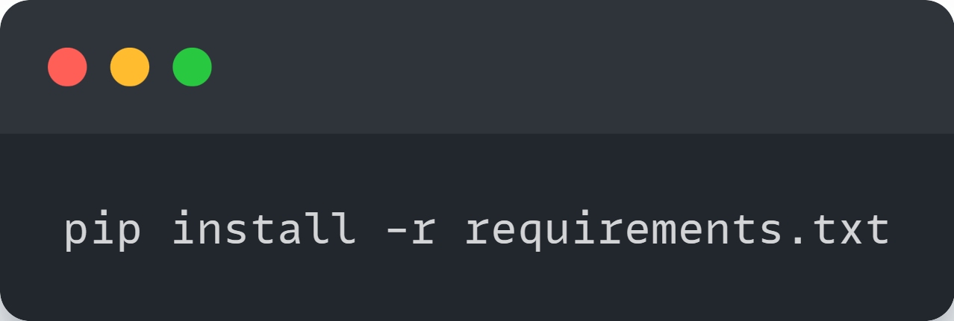
- Verify installation:
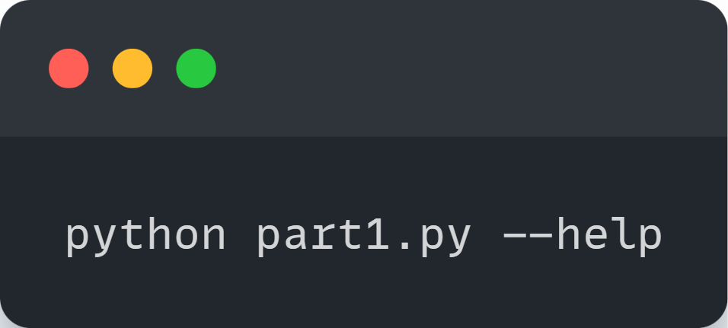

Configuration

Configuration Files
The system uses JSON configuration files:
- physical.json: Defines the physical infrastructure
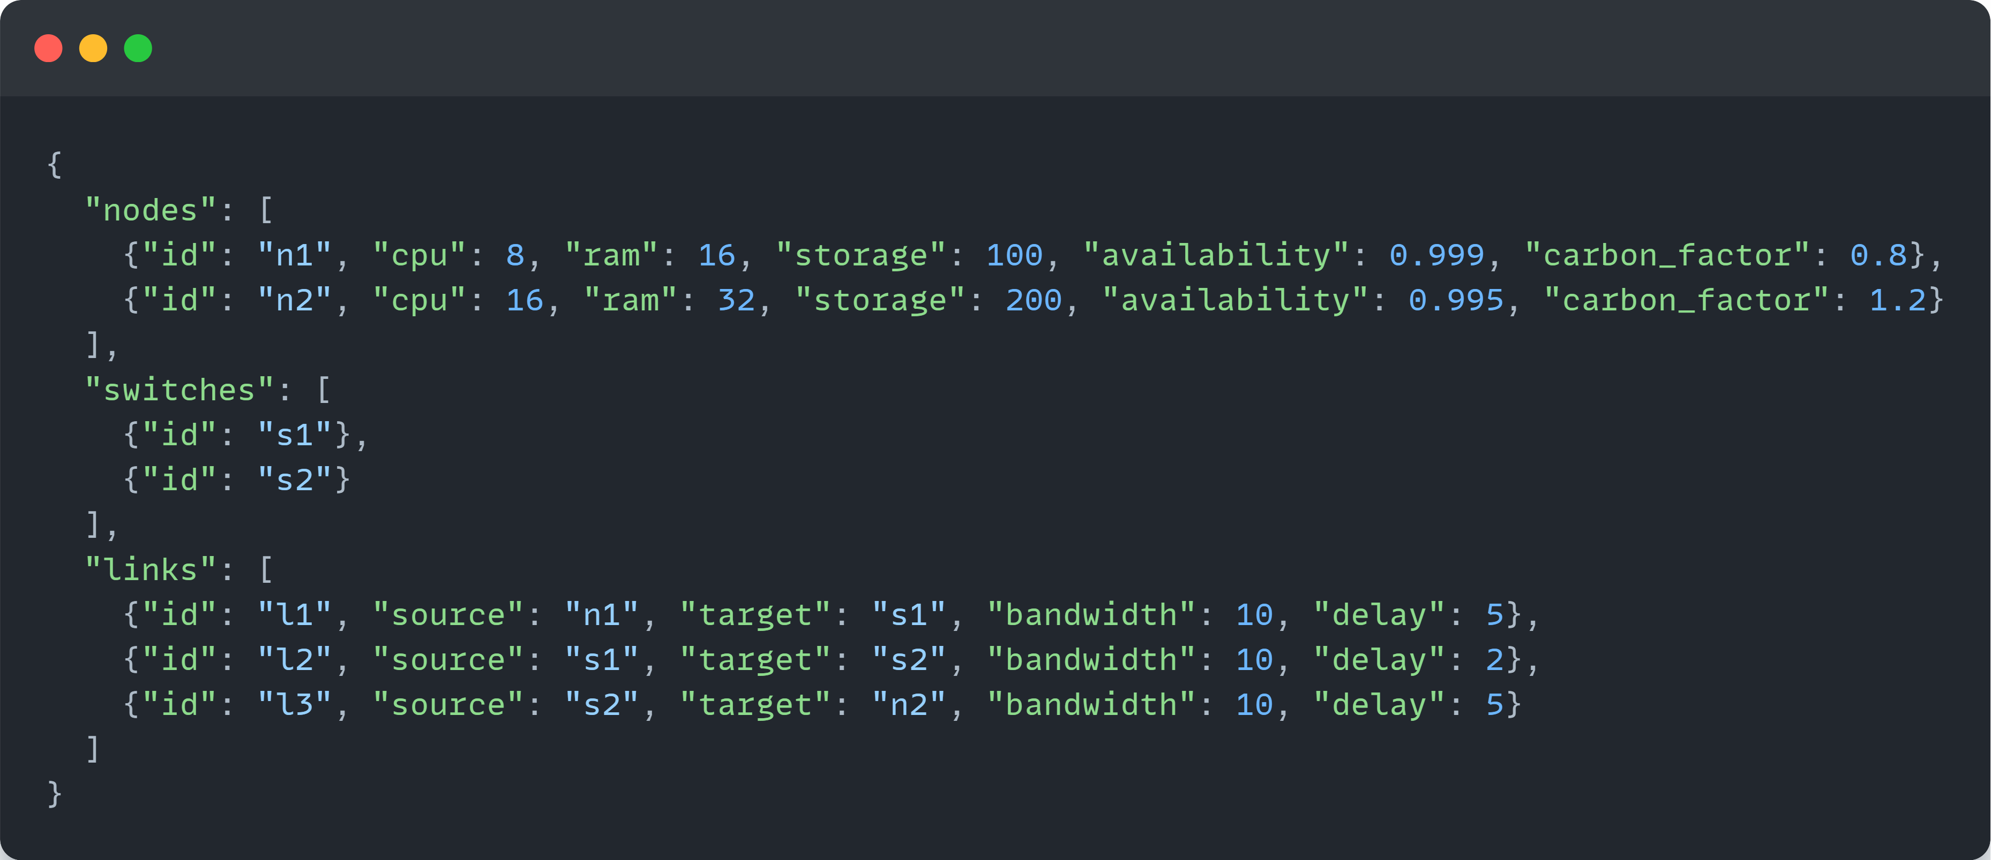
- virtual.json: Defines the service function chains
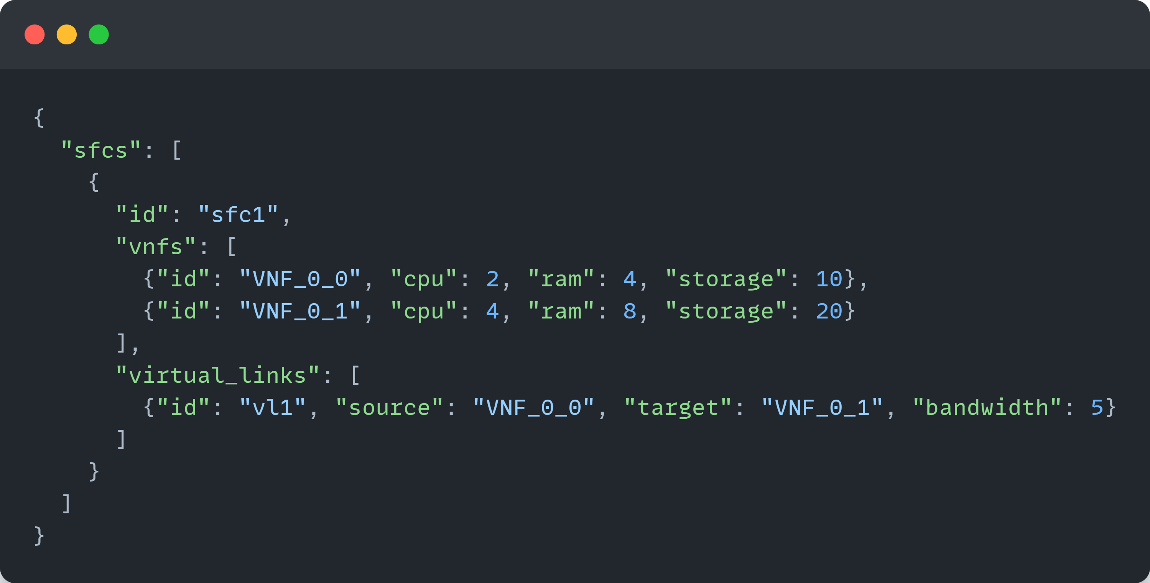

System Configuration
The system is configured through the config.py file, where you can set:
- EMBEDDING_POLICY: Determines VNF placement strategy
  - AAE: Availability-Aware Embedding
  - CAE: Carbon-Aware Embedding
  - TAE: Trade-off Aware Embedding (balances multiple objectives)
- ALLOCATION_POLICY: Determines redundancy optimization strategy (for Part 2)
  - SA: Simulated Annealing
  - GA: Genetic Algorithm
  - PSO: Particle Swarm Optimization
- Systems Parameters
- Optimization Weights
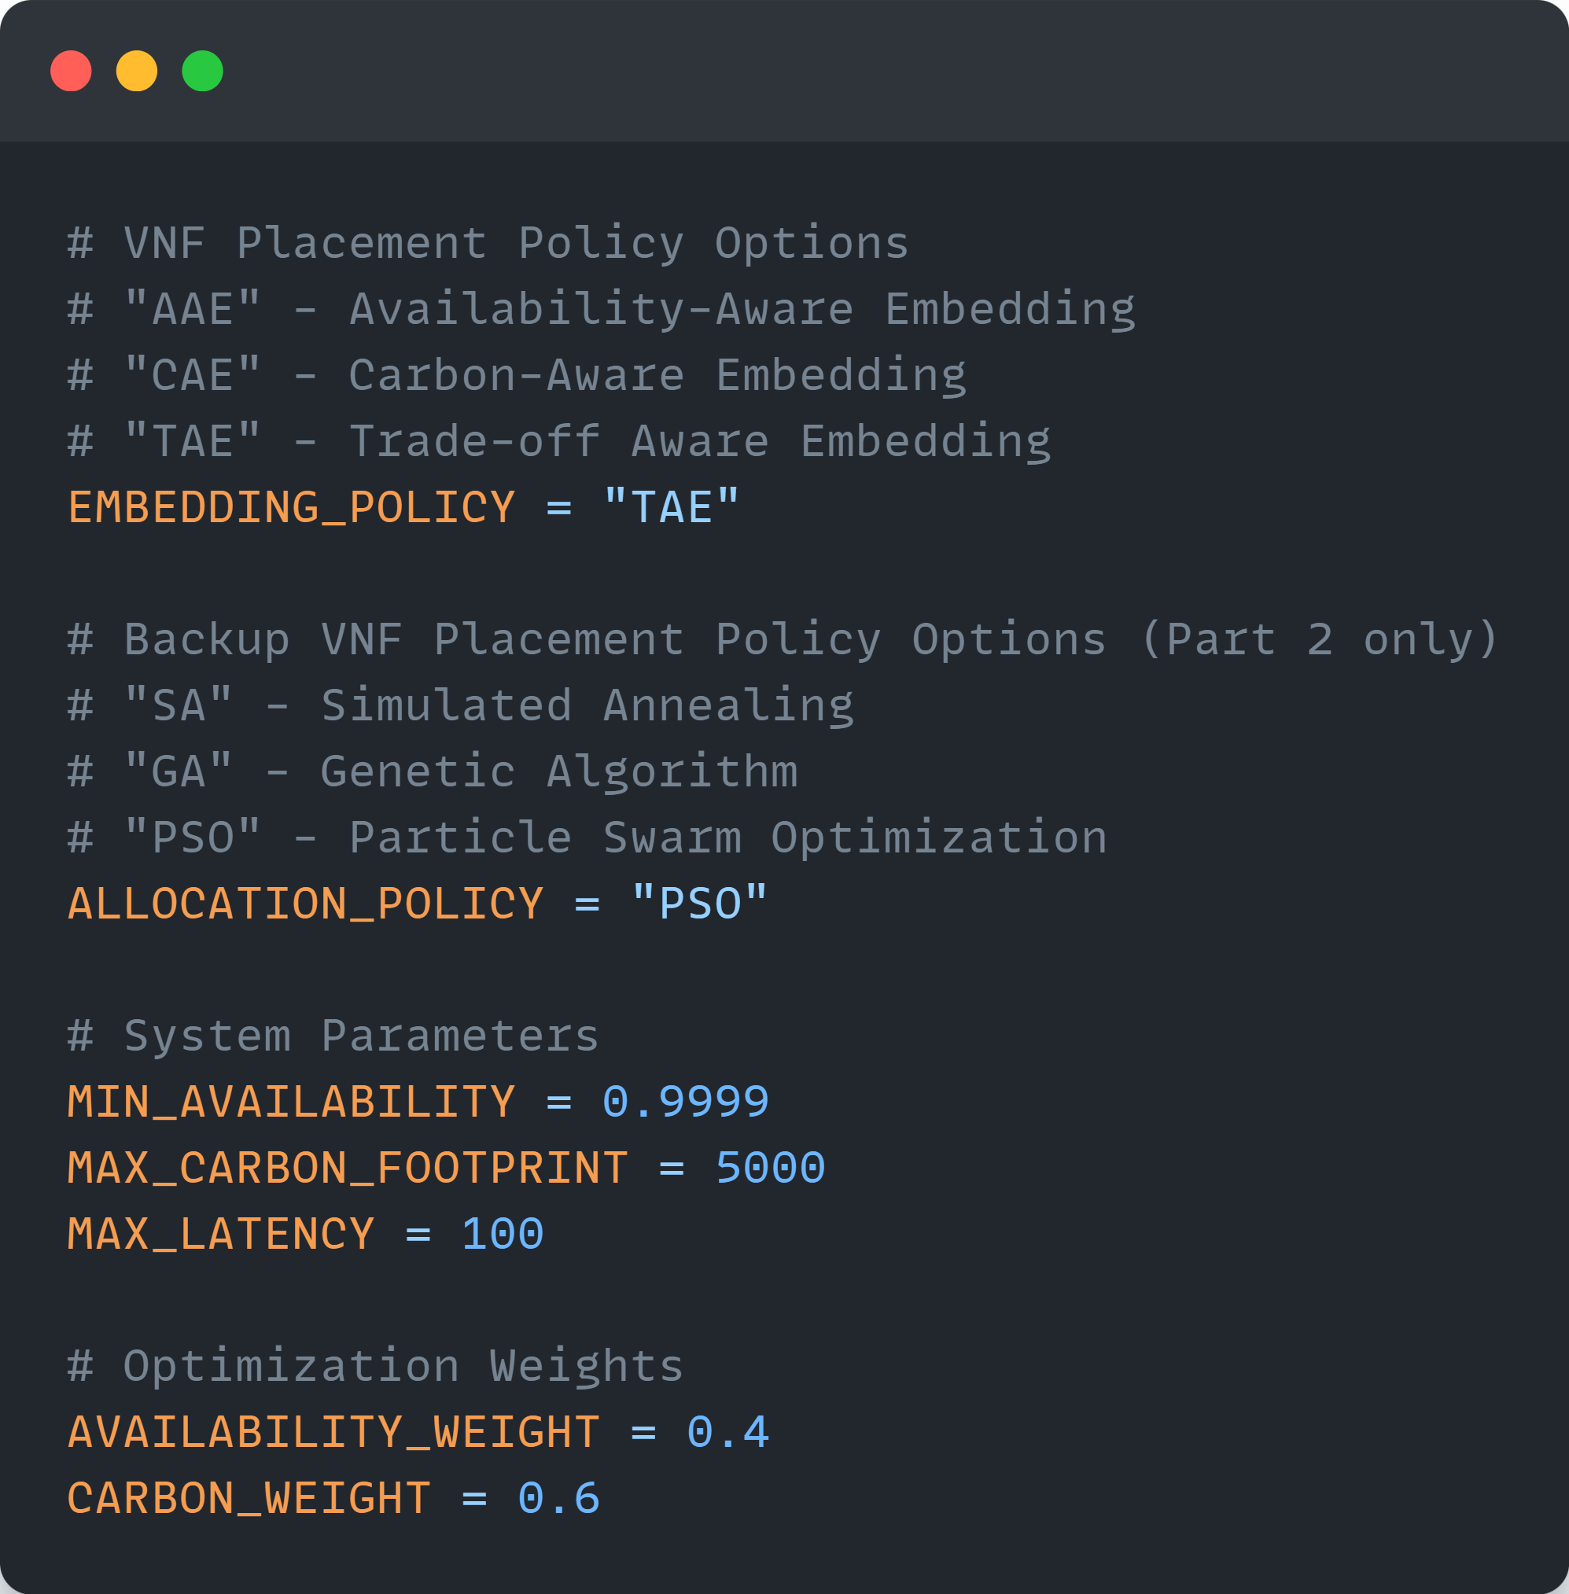

Basic Usage

Part 1: VNF Placement
Part 1 focuses on the initial placement of VNFs without redundancy:
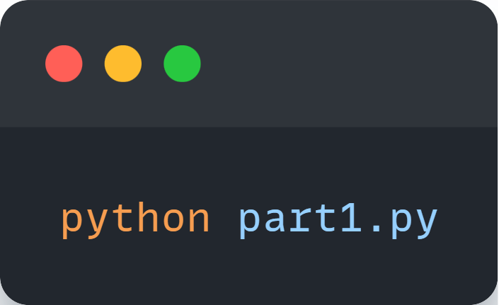
Options:
- --policy <POLICY>: Override the embedding policy from config.py
- --physical <FILE>: Specify a custom physical topology file
- --virtual <FILE>: Specify a custom virtual topology file
- --output <DIR>: Specify the output directory
Example:
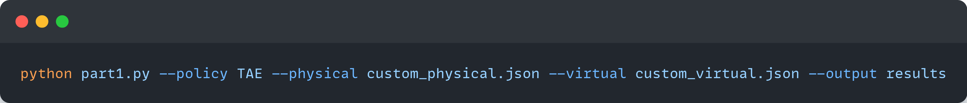
This will:
- Load system topology from configuration
- Apply the selected embedding policy (from config.py)
- Calculate system metrics (availability, carbon footprint, latency)
- Output placement results

Example output:
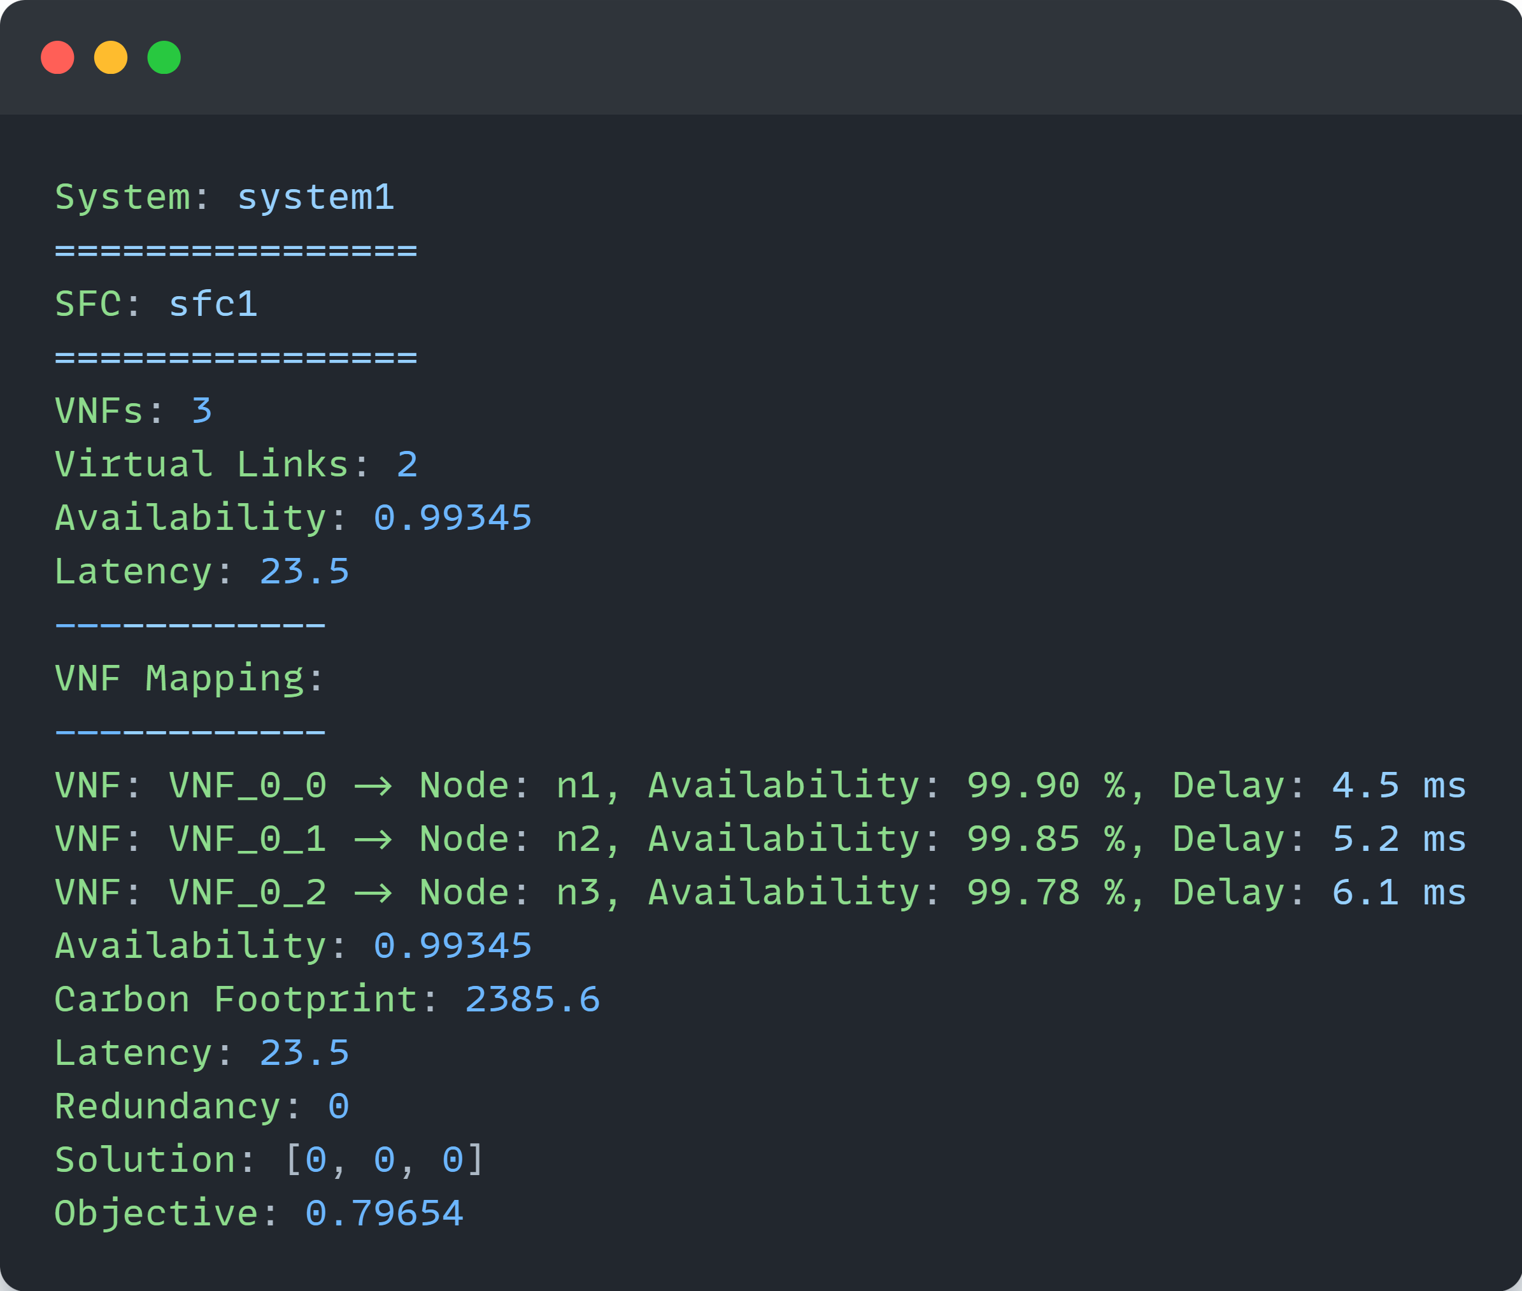

Part 2: VNF Placement with Redundancy
Part 2 extends Part 1 by adding redundancy optimization:
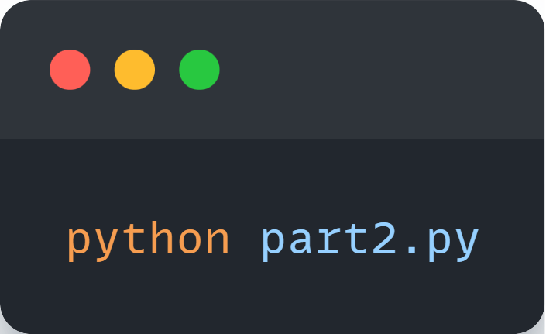
Options:
- --policy <POLICY>: Override the embedding policy
- --allocation <POLICY>: Override the allocation policy
- --physical <FILE>: Specify a custom physical topology file
- --virtual <FILE>: Specify a custom virtual topology file
- --output <DIR>: Specify the output directory
Example:
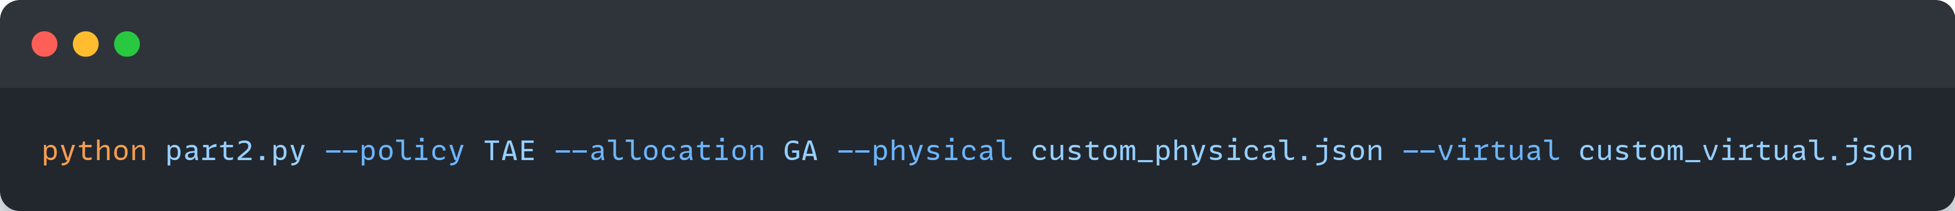
This will:
- Perform initial VNF placement (as in Part 1)
- Apply the selected allocation policy to optimize redundancy
- Place backup VNFs
- Calculate enhanced system metrics
- Output results including backup placements

Example output:
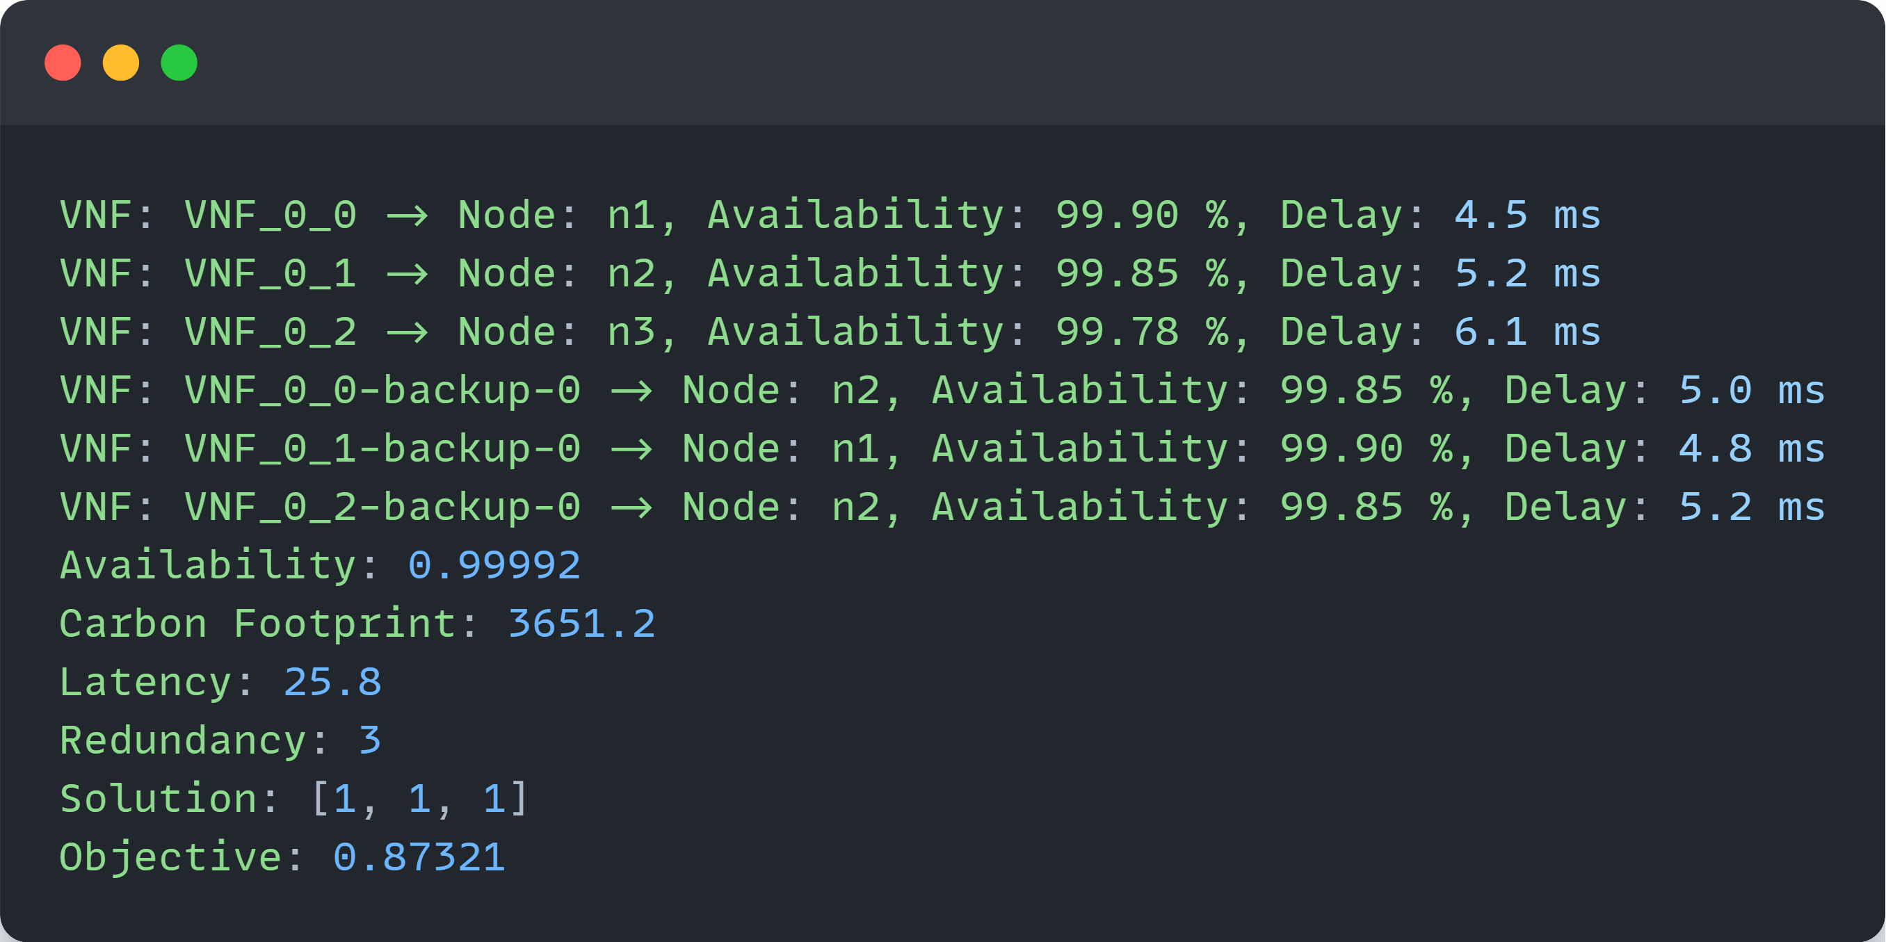

Algorithms

VNF Placement Algorithms (Part 1)
The system implements three primary VNF placement strategies:
- Availability-Aware VNF Placement (AAE)
  - Objective: Maximize service availability
  - Approach: Prioritizes nodes with higher availability values
  - Use Case: Mission-critical applications with strict SLAs
  - Implementation: AvailabilityAwareVNFPlacement.py
- Carbon-Aware VNF Placement (CAE)
  - Objective: Minimize carbon footprint
  - Approach: Prioritizes nodes with lower carbon factors
  - Use Case: Environmentally conscious deployments
  - Implementation: CarbonAwareVNFPlacement.py
- Trade-off Aware VNF Placement (TAE)
  - Objective: Balance availability, carbon footprint, and latency
  - Approach: Multi-objective optimization using weighted metrics
  - Use Case: General-purpose deployments with balanced requirements
  - Implementation: TradeoffAwareVNFPlacement.py

Backup VNF Placement Algorithms (Part 2)
For redundancy optimization, the system implements:
- Simulated Annealing (SA)
  - Approach: Probabilistic optimization with temperature cooling
  - Advantages: Good for escaping local optima, works well with discrete solution spaces
  - Parameters: Initial temperature, cooling rate, iterations
  - Implementation: SABackupVNFPlacement.py
- Genetic Algorithm (GA)
  - Approach: Evolutionary algorithm with selection, crossover, and mutation
  - Advantages: Efficient for complex solution spaces with many variables
  - Parameters: Population size, generations, mutation rate, selection rate
  - Implementation: GeneticBackupVNFPlacement.py
- Particle Swarm Optimization (PSO)
  - Approach: Swarm intelligence with particle position and velocity updates
  - Advantages: Fast convergence, handles continuous solution spaces well
  - Parameters: Swarm size, inertia weight, cognitive/social coefficients
  - Implementation: PSOBackupVNFPlacement.py

Input/Output Files

Input Files
- Physical Topology (physical.json)
  - Defines physical infrastructure (nodes, switches, links)
  - Specifies node resources, availability, and carbon factors
  - Specifies link bandwidth and delay
- Virtual Topology (virtual.json)
  - Defines service function chains (SFCs)
  - Specifies VNF resource requirements
  - Specifies virtual links between VNFs

Output Files
The system generates outputs in the output/{EMBEDDING_POLICY}-{ALLOCATION_POLICY}/ directory:
- Placement Results (placements.txt)
  - VNF to node mappings
  - System metrics (availability, carbon footprint, latency)
  - Optimization objective value
- Backup Placement Results (placements-backup.txt)
  - Primary and backup VNF mappings
  - Enhanced system metrics with redundancy
  - Backup solution encoding
- System State (system_simulator.pkl)
  - Serialized system state for visualization
  - Can be loaded for further analysis
- Updated Topologies (physical.json, virtual.json)
  - Physical topology with updated resource utilization
  - Virtual topology with deployment information
- Metrics Log (metrics.csv)
  - Detailed metrics for each optimization run
  - Useful for comparative analysis

System Components

Core Classes
- System (System.py)
  - Main controller managing the entire deployment
  - Coordinates between physical and virtual components
  - Methods:
    - place_vnfs(): Executes VNF placement
    - place_backup_vnfs(): Executes backup VNF placement
    - calculate_metrics(): Computes system metrics
    - export_results(): Saves placement results
- Node (Node.py)
  - Represents a physical server with resources
  - Properties: CPU, RAM, storage, availability, carbon factor
  - Methods:
    - allocate_resources(): Assigns resources to VNFs
    - release_resources(): Frees resources when VNFs are removed
    - calculate_load(): Computes current resource utilization
- VNF (VNF.py)
  - Represents a Virtual Network Function
  - Properties: Resource requirements, hosting node, backup status
  - Methods:
    - calculate_availability(): Computes VNF availability
    - calculate_carbon_footprint(): Computes VNF carbon impact
    - calculate_latency(): Computes VNF processing delay
- SFC (SFC.py)
  - Represents a Service Function Chain
  - Contains ordered collection of VNFs and virtual links
  - Methods:
    - calculate_end_to_end_availability(): Computes chain availability
    - calculate_total_carbon_footprint(): Computes chain carbon impact
    - calculate_end_to_end_latency(): Computes chain latency
- PathFinder (PathFinder.py)
  - Computes network paths between nodes
  - Implements shortest path and k-shortest paths algorithms
  - Methods:
    - find_shortest_path(): Finds optimal path between two nodes
    - find_k_shortest_paths(): Finds k alternative paths
    - calculate_path_metrics(): Computes path availability, delay

Setup Components
- Topology Generator (topology_generator.py)
  - Creates different network topologies
  - Supports fat-tree and custom topologies
  - Methods:
    - generate_fat_tree(): Creates a fat-tree topology
    - generate_random_topology(): Creates a random topology
- SFC Generator (sfc_generator.py)
  - Creates service function chains
  - Configurable VNF requirements and chain complexity
  - Methods:
    - generate_sfc(): Creates a single SFC
    - generate_random_sfcs(): Creates multiple random SFCs

Troubleshooting

Common Issues
- Resource constraints violated
  - Symptom: Placement fails with resource constraint errors
  - Solution: Increase node resources or reduce VNF requirements
- Availability constraints not met
  - Symptom: System availability below minimum threshold
  - Solution: Lower min_availability or add more redundancy
- Carbon footprint exceeds limits
  - Symptom: Carbon footprint exceeds maximum threshold
  - Solution: Adjust max_carbon_footprint or use more efficient nodes

Advanced Usage

Custom Topology Generation
You can generate custom topologies using the provided generators:
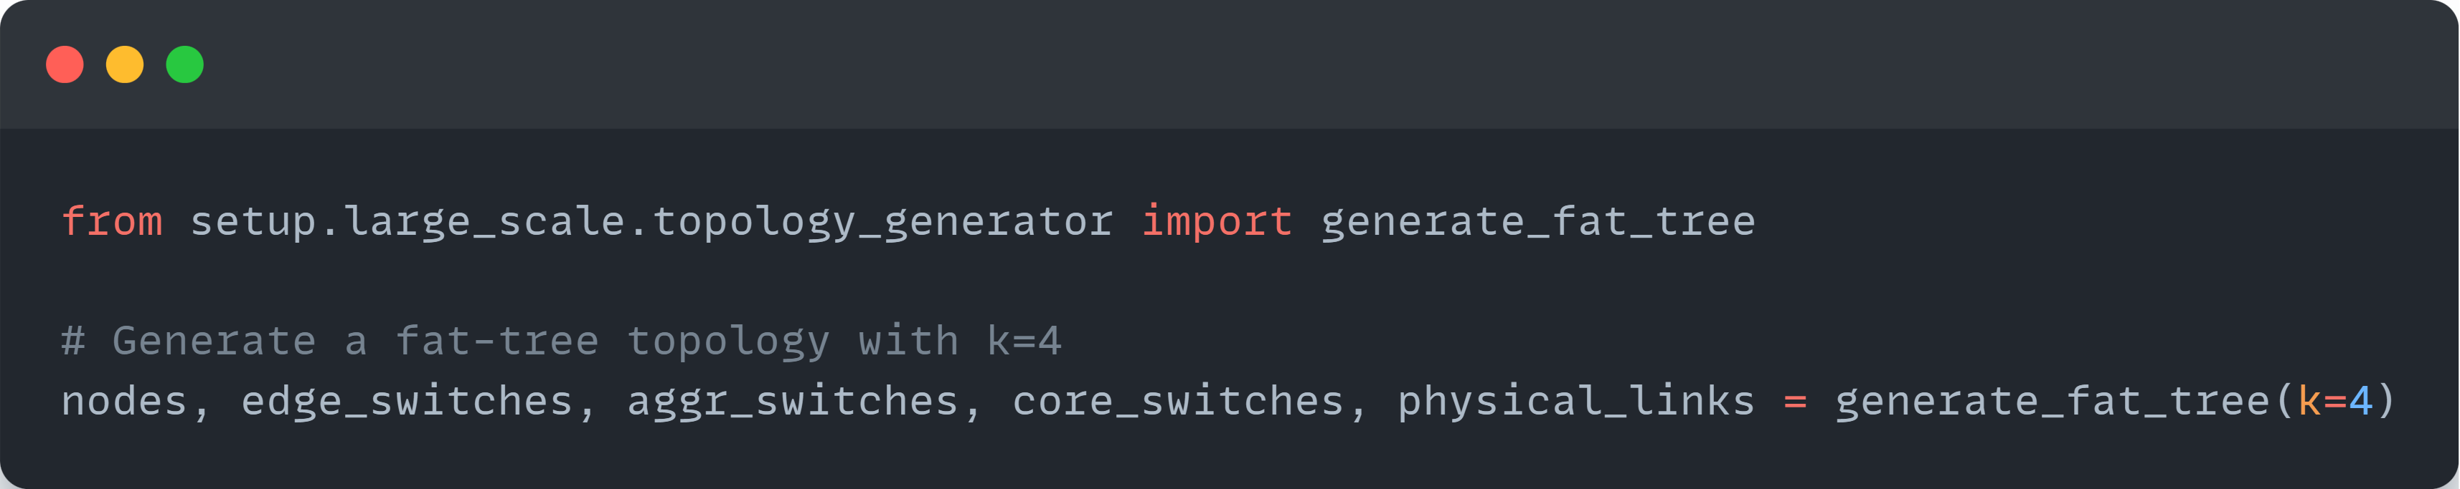

Custom SFC Creation
Create custom service function chains:
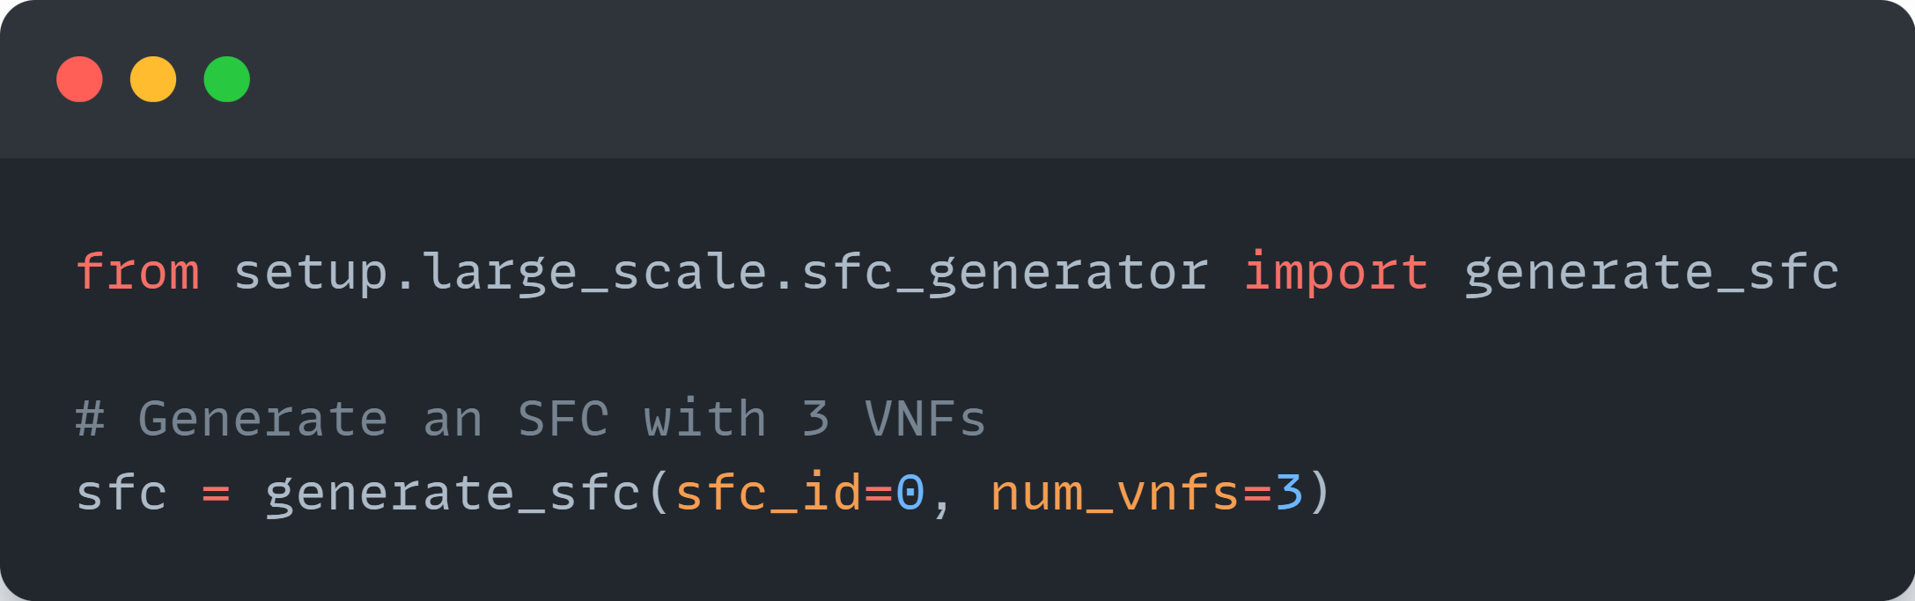

Performance Tuning
For large-scale deployments, tune algorithm parameters:
